
GCSE English Language Unit 1 Exam
Section B: Narrative Writing

Timings
Planning: 10 minutes
Writing: 35 minutes

Examples
1. Trouble in the Street
2. A Fresh Start
3. Stranded
4. My Journey
5. Write about a time when you cheated
6. Write about a time when you were pushed to the limit
7. Continue the following:
It was just a small postcard in the newsagent's window but it caught my eye...
8. Continue the following:
"That's it. Now I'm trapped..."
9. Write a story that ends with the following:
Mum sat down heavily, looked at me and said, "Well, let's just hope it never happens again."
10. Write a story that ends with the following:
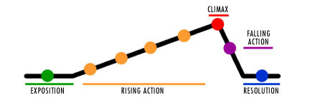
And that's how my heart was broken.
The Short Story Toolbox

Content/Organisation
- Genre
- Original and imaginative
- Plot - keep it simple
- Characters - not too many
- Setting - just the one
- Description
- Dialogue
- Pace and progression
- Paragraphs
- Varied and ambitious vocabulary
- Sensory details
- Language devices
SSPS
- Varied sentence structures
- Accurate spelling
- Accurate punctuation
- Range of punctuation
- Clear written expression
- Control of tense - past tense is best



