
YSGOL BRYN ALYN
CHURCH STREET, GWERSYLLT, WREXHAM, LL11 4HD
Tel: (01978) 720700
Website: www. ysgolbrynalyn.co.uk
e-mail: mailbox@ysgolbrynalyn.wrexham.sch.uk

Headteacher: Mrs Adele Slinn, B.A. (Hons.) NPQSL, NPQH

November 2025
Dear Parent / Guardian of Year 7,

Autumn Term Assessment Week 2025 – 9th December to 16th December 2025

Following my recent letter to you regarding you son / daughter’s Assessment Week, please find below the assessment timetable for Year 7:

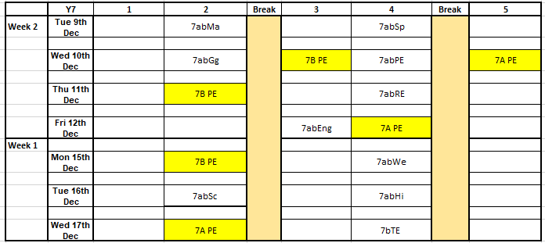

Please note:
- Where there is a blank on the timetable, pupils will be provided with knowledge organisers and / or revision booklets to assist with their preparation for their assessment.
- Where it states 7A PE and 7B PE, this is a PE lesson and not an assessment or revision period. Pupils must bring their full PE kit to school on that day.
- Pupils in the Achievement Centre, Reach Centre or ALN centre will follow a bespoke programme for their assessment and revision week.

If you require any additional information, please contact your son / daughter’s Head of Year in the first instance.

Yours sincerely

Mr Ransome


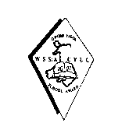

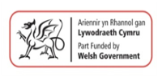



Senior Assistant Headteacher

