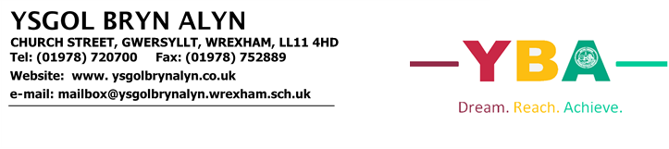

Guidance Information for Parents/Guardians regarding YBA return September 2020
Thank you for your continued support during this unprecedented time. As you will be aware, the Minister for Education announced on 9th July that all learners would return to school in the autumn term. The Welsh Technical Advisory Group (TAG), which provides scientific and technical advice to Government during emergencies, recommends that schools “plan to open in September with 100% of pupils physically present on school sites, subject to a continuing, steady decline in the presence of COVID-19 in the community.” As a result of this announcement and the guidance that has followed, we are looking forward to seeing our pupils once the September term begins. The purpose of this letter is to set out how we plan to open the school and minimise the COVID-19 risk to our community.
Summer Learning
Many of our pupils have successfully engaged with the home learning via Google classroom over the last 3 months. However, for some of our families this has been a challenging time, and without the structure of the school day and teachers to support their son or daughter, engaging with home learning has been difficult.
Ysgol Bryn Alyn understands that not all pupils have completed the set work on Google Classroom, and the school is in the process of planning for intervention for the pupils that have fallen behind. However, we feel it is essential that our pupils engage in some learning over the summer break.
Our staff will be setting summer learning for all year groups. This work will be optional and teachers will not be providing feedback. However, we feel that for some of our pupils it is essential that they ‘Check In, Catch Up and Prepare for September’. Below we have outlined what we would consider essential summer learning for our pupils.
Year 10:
For pupils to achieve the highest grades possible at the end of Year 11 it is vital that these pupils have attempted to complete tasks set on Google Classroom across all subjects. Staff will have limited curriculum time in Year 11 to cover both missed content and new content needed for pupils to be successful. To support parents and pupils in catching up and preparing for September a document called Year 10 Home Learning Summary has been created which provides you with an overview of all the activities pupils should have completed across a range of subjects. This document also includes extension tasks for those pupils who are up to date with their home learning.
Year 9:
Year 9 pupils should focus on completing English, Mathematics and Science work as outlined in the Year 9 Home Learning Summary document.

Year 7 & 8:
Supporting your son or daughter with both their literacy and numeracy skills will help them to be successful learners both in September and throughout their time in school. This can be achieved by encouraging them to revisit activities on both Literacy Planet and Maths Watch; to read books or magazines to develop their vocabulary and discussing current topics with them to support their oracy skills.
September Return
School will be a very different place for our pupils. Some have already experienced YBA with the stringent pupil bubbles in place over the past three weeks and the robust personal handwashing/sanitising and area cleaning. However, following the guidance, YBA will continue to ensure that our pupils, staff and parents are prepared – mentally, emotionally and practically for the ‘new normal’ this coming September.
With this in mind, we have created a robust Risk Assessment to recognise the Government guidance and ensure, as thoroughly as we can, our community’s safety.
Health and Safety Guidelines
Our primary concern is to keep everyone safe. The virus is still in circulation in our community and all our plans are to mitigate the risks involved in having over 750 students and approximately 60 staff in the same buildings.
- There are hand sanitiser stations at every entrance and located in every classroom. Students will be asked to wash hands or use the sanitisers as frequently as possible.
- All students are encouraged to bring their own personal hand sanitiser.
- Teachers in close contact with pupils may wear a mask or visor. This is a school recommendation and not guidance from the Government.
- The issue of facemasks is a controversial one, with conflicting advice from scientists. If students wish to use them, they can, however, we are not in a position to supply them and we urge you NOT to use single use masks. We would urge all parents/carers to discuss this matter with their children and educate them on the correct way to wear a mask and should they wish to remove it, how to store it safely during the day. The following links offer some advice on making masks and on basic safety instructions.
https://www.gov.uk/government/publications/how-to-wear-and-make-a-cloth-face-covering
https://gov.wales/face-coverings-frequently-asked-questions
https://www.youtube.com/watch?v=SfZmWJOUEh0
- In order to control the flow of students around the school we have initiated a one way system and this is to be adhered to at all times.
- All water fountains will be disconnected and students should bring their own drinks and snacks.
- Toilets will be allocated in year zones and will be cleaned on a regular basis. Students must ensure they ONLY use the toilets allocated to their year zone. (see further information below)
- All classrooms will have desks arranged to minimise pupil face to face positioning/interaction.
- Staff will maintain a minimum of 1m distance from students in all classrooms at all times.
- We will have our own cleaning team on duty throughout the day and there will be frequent cleaning of the site.
- Each year group bubble will have their own social area and this must be adhered to at all times. Students should not wander into the social areas of other year bubbles.
- Staff will enforce the ‘catch it, bin it, kill it’ message.
- When following the school day students will be required to exit out of the building after each lesson, this is to minimise the traffic in corridors and to alleviate possible crowded areas. We do expect all students to follow the restrictions that are in place e.g. keeping appropriate distances from each other and obeying no entry signs and one-way systems.
- No contact sports can be played at either breaks or lunchtimes.
- Due to the restrictions of zoning pupils, we will be unable to offer canteen facilities at break time and students should bring their own snacks and drinks for this time. There will be a reduced menu that will be offered to our students on a strictly pre-order basis for lunch, food will be brought to the year group zones. Please see further information below regarding arrangements for ordering. However, we request, if possible, students bring their own packed lunches.
- Key Stage 3 PE lessons and core Key Stage 4 lesson (statutory) will be taking place in a classroom until October half term when a review will take place. GCSE PE students will be completing any PE activities in their uniform, however, there will be no contact sports taking place.
- There will be no school fixtures of any of our team sports until we are cleared to do so.
- There will be no extra-curricular activities taking place this term and we will review this decision following further guidance.
- If you require a meeting with a member of staff, please contact our school office and arrangements will be made to accommodate you.
The safety and well-being of our community is our absolute priority and we have made careful and extensive preparations to ensure a safe return for all.
We will expect all pupils to return to school in a phased reopening from Thursday 3rd September
Students will have a number of new systems and structures to learn and just as businesses reopening will have needed to take time to train their staff, we are extending the return of year groups so that we can focus on a year at a time each day.
See table below for guidance regarding individual year group starts.
Date | Year group expected in school
Thursday 3rd September | Year 7 |  |  |  | Year 11
Friday 4th September | Year 7 |  |  |  | Year 11
Monday 7th September | Year 7 | Year 8
Tuesday 8th September | Year 7 |  | Year 9
Wednesday 9th September | Year 7 |  |  | Year 10
Thursday 10th September | Year 7 |  |  |  | Year 11
Friday 11th September | Year 7 | Year 8 | Year 9 | Year 10 | Year 11

For clarification, October half term will consist of one holiday week. School will be closed Monday 26th October until Friday 30th October 2020.
Please do not take holidays during term time.
Pupil Attendance Arrangements
All pupils are expected to attend school from their September start.
We would encourage all students to either walk or cycle to school. Parents who drive their children to school should not share a car with anyone outside their family bubble. At drop off and pick up time we ask parents to arrange a safe place away from the main school entrances.
Social distancing has significantly reduced available transport capacity and the advice we are giving is that where possible, students should avoid public transport.
School transport will be in operation. Currently our understanding is, facemasks or face coverings will be needed if a pupil is travelling to school on the bus (as per Government guidance).
Social distancing will remain in place. If your child walks to school, please re-enforce the need for social distancing with them. Pupils should be 2m from any other pupil who is not from their family home.
If your child is unable to attend school, it is essential that you follow the normal absence recording procedure (see below).
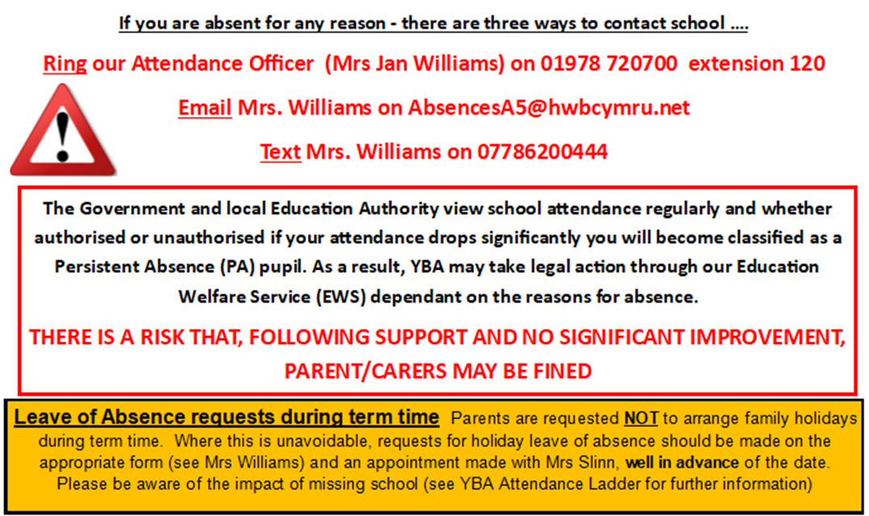
Please inform us immediately should your child be suffering from COVID-19 symptoms. DO NOT send your child to school if they have a high temperature, new persistent cough, loss of taste and/or smell.
One of our meeting rooms will be the isolation area should anyone develop symptoms during the school day. If this is the case, you will be notified and asked to collect your child. Please inform school as soon as you can if your child has tested positive for COVID-19.

Engage with the NHS Track and Trace process

Together, school and parents must ensure that we understand the NHS track and trace process and how to contact our local Public Health Wales Protection team. Parents/carers will need to be ready and willing to:
- Book at test if they are displaying symptoms. Students must not come in to school if they have symptoms and will be sent home to self isolate if they develop them in school
- Provide details of anyone they have been in close contact with if they were to test positive for COVID-19 or if asked by the NHS Track and Trace.
- Self isolate if they have been in close contact with someone who develops COVID-19 symptoms or someone who tests positive for COVID-19
Anyone who displays symptoms of COVID-19 can and should get a test. Test can be booked online through Track and Trace for COVID-19 website or ordered by telephone by NHS 119 for those without access to the internet. Essential workers, which include anyone involved in education or childcare, have priority access to testing.

Track and Trace website
https://www.nhs.uk/conditions/coronavirus-covid-19/testing-and-tracing/nhs-test-and-trace-if-youve-been-in-contact-with-a-person-who-has-coronavirus/

We ask that you inform us immediately of the result of the test…
- If someone tests negative, if they feel well and no longer have symptoms of COVID-19 they can stop self isolating. They could still have another virus such as a cold or flu in which case it is still best to avoid contact with other people until they are better. Other members of their household can stop self isolating.
- If someone tests positive, they should follow the ‘stay at home guidance for households with possible or confirmed COVID-19 infection’ and must continue to self isolate for at least 7 days from the onset of their symptoms and then return to school only if they do not have symptoms other than a cough or loss of sense of smell/taste. This is because a cough or anosmia can last for several weeks once the infection has gone. The 7 day period starts from the day when they first became ill. If they still have a high temperature, they should keep self isolating until their temperature returns to normal. Other members of their household should continue to self isolate for the full 14 days.
In the even to a local outbreak, Public Health Wales protection team or Local Authority may advise us to close temporarily to help control transmission. We have a contingency plan for this eventuality. This may involve a return to remaining open only for vulnerable children and the children of critical workers and providing remote education for all of the students.

Where a class, group or small number of students need to self isolate or there is a local lockdown requiring students to remain at home, we will instantly revert to home learning via Google Classroom.

Uniform, Equipment & Home learning

Pupils will attend school in uniform, as per usual. Please refer to our updated guidance on YBA school uniform on the school website at https://www.ysgolbrynalyn.co.uk/parents/uniform-2/. Just a reminder – only the standard school skirt is allowed and trousers must be tailored cut and straight legged (NOT slim or skinny fit). All pupils are expected to be in school shoes.

It is recommended that pupils shower as soon as they return from school and change their clothing in order to help minimise the COVID-19 risk.

Each pupil will need their own pack of equipment that is strictly for him or her, this must not be shared. We request that all equipment is placed in a pencil case which is clearly labelled.
Essential Equipment | Suggested Equipment
- Pencil Case  - Pen  - Pencil  - Pencil sharpener  - Rubber  - Ruler  - Glue stick  - Highlighter  - Purple Pen | - Scientific calculator  - Geometry set  - Coloured pencils  - Coloured pens  - Scissors  - Headphones (for use in ICT lessons)

We are discouraging students from sharing equipment in order to mitigate against infection, hence the two lists above. Although the first list is essential, if you can provide your child with the equipment stated in BOTH lists above this will support us in minimising the risks.
Exercise books will remain in school, in class boxes. Home learning will be set on Google Classroom.
Arriving / Leaving School

On arriving at school, all pupils will enter the school site through the front gates – no other gates will be open. From Monday 7th September, on arrival pupils must immediately make their way to their allocated entrance, adhering to social distancing guidelines. Students should not arrive at school before 8.30am when supervision begins.

At the end of the school day students exit from the building will be staggered over 20 minutes. Some students will not leave their classes until 3.10pm, buses will be held back accordingly.
- Years 7 & 8 will leave at 2.50pm
- Year 9 will leave at 3pm
- Years 10 & 11 will leave at 3.10pm
Gathering outside of school will be discouraged.

All pupils, on entering the building at any entrance – will be expected to sanitise their hands. Pupils entering and exiting classrooms will be expected to sanitise their hands. When in the classroom, all pupils will be expected to remain at their desk for the time that they are in their classrooms to minimise disruption and ensure safety for all.
Year 11 Arrangements – Thursday 3rd September & Friday 4th September
On returning to school in September, Year 11 will follow a bespoke timetable for the Thursday and Friday, this will focus on key qualifications and give our pupils some time for catch up. The Year 11s have the opportunity via their Google Classrooms to complete work set that supports these qualifications over this summer – staff have been supporting work on these qualifications since the beginning of lockdown. (Equality & Diversity, Skills Challenge and Highfield Courses).
Year 11s will need to make their way on to our school site via the entrance gate at the front of school and then make their way around to their designated building entry point. Please see overleaf.
Exit and entry | Exit and entry | Exit and entry | Exit and entry | Exit and entry
Science Ramp Exit | Science Ramp Exit | Science Courtyard | Science Courtyard | English / Science Exit
11Y | 11S | 11O | 11L | 11B

Movement around the school building will be strictly limited on our pupil return (see detailed information later on). However, on these two days, Year 11 will be remaining in the Science block. They will be allocated the Science block toilets on these two days too. Pupils will be expected to sanitise their hands, via the dispenser at the entrance of their classroom on entering and exiting the room.
Pupils are to remain in their allocated space at all times unless entering or exiting the room.
Lunch arrangements for these two days – PLEASE BRING PACKED LUNCH. The canteen will NOT be open.
Year 7 Arrangements – Thursday 3rd September & Friday 4th September
On returning in September, our ‘new’ Year 7 pupils will be doing a two-day transition programme. This will mean that, like Year 11, they will be within certain areas. They will meet their form tutors on the top yard each morning and enter the Maths Corridor (where their form classes are) via the Music/Top Yard entrance.
Exit and entry | Exit and entry | Exit and entry | Exit and entry | Exit and entry | Exit and entry
Top Yard | Top Yard | Top Yard | Top Yard | Top Yard | Top Yard
7Y | 7S | 7G | 7O | 7L | 7B

During these two Transition days, our Year 7 pupils will take part in a number of activities e.g.
- Form time – a chance to meet your form tutor and those pupils in your form as well as find out more about the school!
- Assembly – a welcome assembly that will be presented by Mrs Slinn
- Activities such as Drama, Physical Activity (don’t worry you don’t need PE kit), Music, Maths, English, Science and Languages
- You will get the opportunity to register on our Biometric System so that if you choose to have school dinner after your transition days – you can! Your thumb print will be taken so it is very specific to you.

Lunch arrangements for these two days – PLEASE BRING PACKED LUNCH. The canteen will NOT be open apart from to register ‘thumb prints’ for our biometric system
From Monday 7th September
On Monday 7th September our year groups will be introduced one year at a time. As stated above, entrance on to our school site will be via the main front gate ONLY. Each year group has been allocated a year group ‘area’ to be used before school, breaks and lunchtimes and students must make their way to these areas immediately after arrival on site.
Year 7 & 8 Outside Classroom and Top Yard
Year 9 Canteen and Prince’s Trust Garden
Year 10 Science Courtyard and MUGA
Year 11 Pupil Entrance Courtyard and outside area around New Block.
The school will be operating on a one-way system (please see attached map to help your son/daughter familiarise themselves with this). Students will be asked to vacate the school buildings after each lesson out of the nearest exit and the majority of movement will be outside the school building, in order to mitigate the risk of COVID-19 in confined or busy areas. There will be clear signs to inform our community of stringent entries and exits to buildings and one-way systems will be in operation in our corridors (there will be a video produced during the summer to help our pupils visualise this).
Our year groups are zoned for their form time (as in previous years) and so will need to make their way to their correct entrance into the building – please see below and form information at the end of this guidance;
Year 7 entry from Top Yard into the Maths corridor (our new pupils will be shown all this during their two transition days) where their form zone is.
Year 8 entry from Top Yard via the Languages stairs (if their form rooms are in Room 16, 15, 14, 13) and via the Music entrance if in room 7. If in room 9 via the Art Room Fire exit (opposite the top yard)
Year 9 entry via the Pupil Entrance at the front of school (one way down Welsh and English corridor to form rooms)
Year 10 entry via the Science ‘ramp’ into the Science block (there is a one-way system operating in the Science block – entry only via the ‘ramp’ and exit only into the Science courtyard)
Year 11 entry to the New Block via the ‘pond entrance’ (exit from this area is through the New Block doors)
Remember on entering the buildings and classrooms – hands must be sanitised at the hand sanitisation station.
Once form time is over (extended form time will take place on the year group designated day to go through safety protocols, new timetables, our one way system and lunchtime arrangements), pupils will be moving to their timetabled lessons. They must follow the one way system and ask if unsure (staff will be visible in the corridors to help with this) – please refer to the map of entry and exits into building. Form time will be used to explain the system to pupils and take them on a tour of the school to familiarise themselves with it.
Each year group have been allocated their own toilets. All pupils are only to go to the toilets that are allocated to them.
Year 7 & 8 Boys’ toilets in the Maths Corridor, Girls’ toilets by Music room
Year 9 Boys’ toilets by Room 17, Girls’ toilets by Library
Year 10 Science toilets
Year 11 New Block toilets
Lunch arrangements – the Canteen will be open BUT will only be serving pre-ordered food (this is to help minimise crowding in the canteen). Pupils WILL NOT be able to deposit money via the machines. Parents will need to use our online system to pay money into their son/daughter’s lunch account. Pupils will be able to preorder their lunch during form time and this will be delivered to their year group zones.
Behaviour
We acknowledge that some students will return to school having been exposed to a range of adversity and trauma including bereavement, anxiety and, in some cases, increased welfare and safeguarding risks. This may lead to an increase in social, emotional and mental health concerns for some young people. Staff have received training on how to help students cope with the anxiety that they may feel when returning to school and we know that a degree of readjustment is needed.
We have very clear behaviour expectations and will continue to uphold the standards that you expect of us. Any student who wilfully flouts the health and safety processes that have been put in place, or who threatens the health and wellbeing of staff or students, can expect to be dealt with in accordance with our behaviour policy and this includes being sent home as a Fixed Term Exclusion. This could lead to a Permanent Exclusion as the safety of our community is paramount.
Assessment and Reporting
Our Assessment and Reporting framework will run as normal. This means test, mock exams and interim and final reports will remain in place. There will be some amendments to the timings of some of these and all key dates will be accessible from the school website. During the autumn term teachers will be assessing all students to enable them to find out where each student is in terms of knowledge and understanding of the key elements of each subject. This will allow staff to put in place appropriate support programmes for each student. The recovery of lost learning will be a long term process, it is not something that can or will be completed in one term. Staff will plan the recovery curriculum based on the outcome of regular assessments and tailor provision accordingly. Further adjustments to our curriculum and processes will be considered if they prove necessary, for example, extending the school day, catch up classes, the use of support tutors etc. These decisions will be made based on the judgements of class teachers and will be different for each student.
It is also clear that parents evening will not be able to run as they have done in the past. We will inform you of the new format in due course.
Final Thoughts
Returning to school is vital for children’s education and for their wellbeing. Time out of school is detrimental for children’s cognitive and academic development, particularly for disadvantaged children.
The risk to children themselves of becoming severely ill from COVID-19 is very low and there are negative health impacts of being out of school. We know that school is a vital point of contact for public health and safeguarding services that are critical to the wellbeing of children and families.
We have taken the measures we have to ensure that school can be as safe as we can make it – but there are no risk free solutions.
There are essential measures we must ALL take to ensure we ALL stay safe:
- a requirement that people who are unwell with symptoms of COVID-19 stay at home
- robust hand and respiratory hygiene including ventilation
- continue increased cleaning arrangements
- active engagement with Test, Trace, Protect
- formal consideration of how to reduce contacts and maximise distancing between those in school wherever possible and minimise potential for contamination so far as is reasonably practicable.
How contacts are reduced has been left for each school to determine, based on each school’s circumstances and will, as much as possible, include:
- grouping learners together
- avoiding contact between groups as much as possible
- arranging classrooms with forward facing desks, recognising this may not be possible or appropriate in all schools/settings
- staff maintaining distance from learners and other staff as much as possible
However, health and safety, is everyone’s concern. We all have a role to play in keeping ourselves and others safe. I cannot give you a guarantee that what we have done means that the school is risk free – it isn’t. We have done all that we can think of to minimise the risk and by working together in partnership and looking out for each other we can keep those risks to an absolute minimum and all come through this together.
If you have any questions or comments then please, in the first instance, contact the relevant Head of Year and we will do our best to answer them but I hope this guide has provided you with the assurance that Ysgol Bryn Alyn is as safe as we can make it.
Many thanks for taking the time to read this document. It is highly likely that the guidance we are working to will change at some point in time and we will react accordingly. This document will now be posted on our website and amendments made as and when it proves necessary, we will of course, alert you to any changes.
We are all going to need some patience and understanding in the months ahead and I know I can rely on the cooperation of students and parents to help us through what will be a very unique autumn term.
On behalf of everyone at Ysgol Bryn Alyn, I hope you all have a great summer break and we look forward to welcoming all our students back, full time, in September.
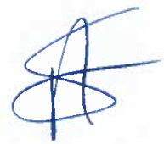
Mrs A. Slinn
Headteacher

