Name:


Year 11 Revision Planner
Get Ready for Summer GCSE Exams 2026

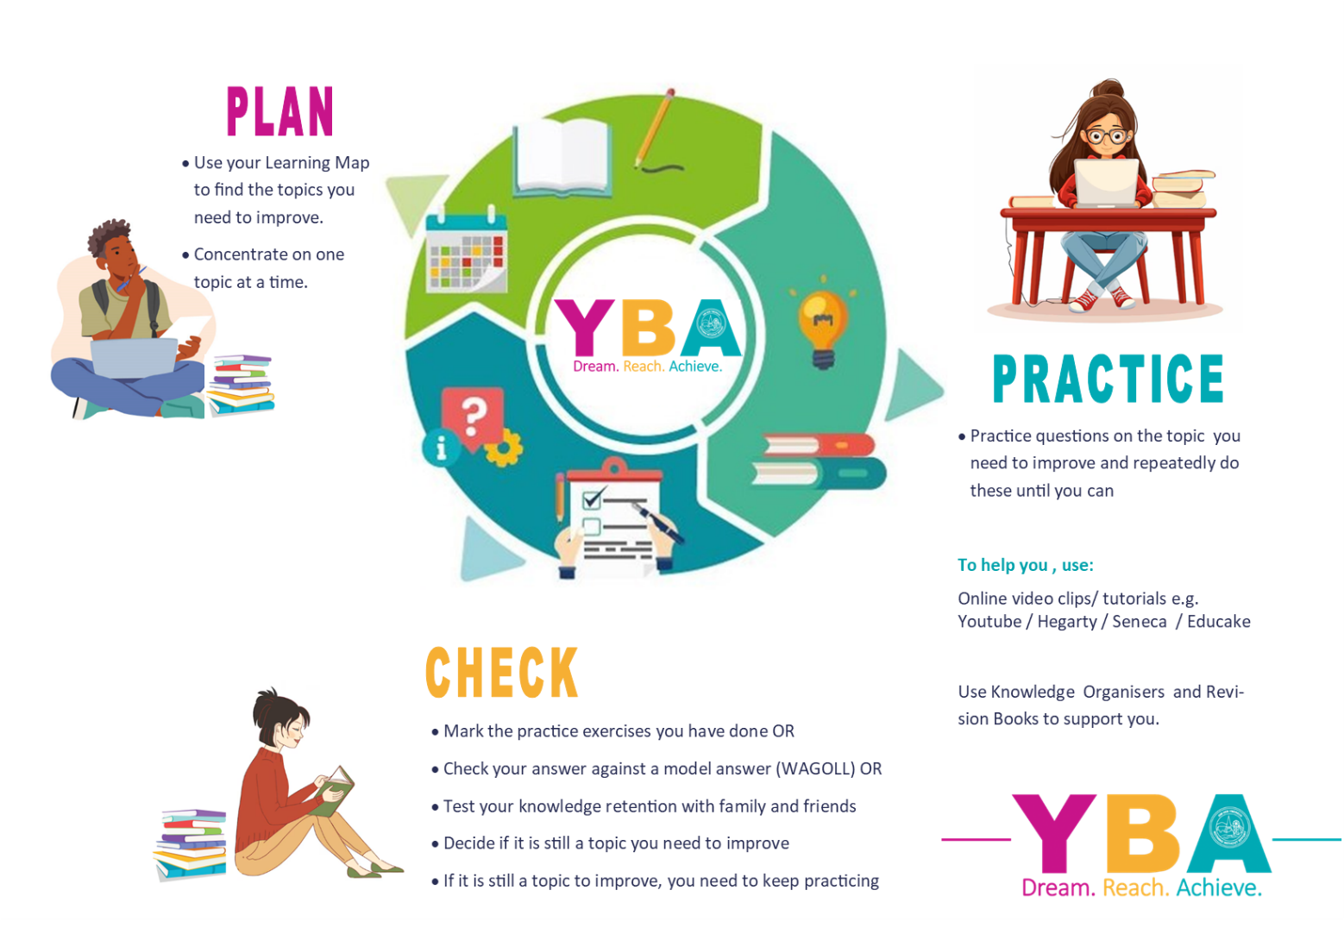
e class: 3S2U88

do I prioritise my child’s revision?



6 habits of highly successful students

- Spaced Practice: NO CRAMMING. Short, regularly spaced-out study periods over time.
- Interleaving Topics: SWITCH topics regularly, making links between ideas.
- Elaborate: ASK, EXPLAIN AND CONNECT. Explain how or how things work and connect them to your daily life and experiences.
- Concrete Examples: look for real life EXAMPLES you can relate to understand an idea you are learning.
- Duel Coding: combine WORD AND VISUAL materials giving you 2 ways of remembering information
- Retrieval Practice: put all of your revision away and RECALL EVERYTHING YOU KNOW about a topic. Check it against your revision materials later.

YOU make this happen. We will help you, but the success will be yours. We all want you to do well and everyone wants to help and encourage you!

GO FOR IT!

Revision Timetable – from now to your first mock exam

(Two 45min sessions EVERY night. Write down the subject and topic which you need to improve in)

Revision Times |  | 1st 45-minute Revision Session | 2nd 45-minute Revision Session
Example |  | English Literature  The character arc of Macbeth | Science  12+ mark question on Biology Paper 2
Monday | 23 Mar
Tuesday | 24 Mar
Wednesday | 25 Mar
Thursday | 26 Mar
Friday | 27 Mar
Saturday | 28 Mar
Sunday | 29 Mar
Monday | 30 Mar
Tuesday | 31 Mar
Wednesday | 1 Apr
Thursday | 2 Apr
Friday | 3 Apr
Saturday | 4 Apr
Sunday | 5 Apr
Monday | 6 Apr
Tuesday | 7 Apr
Wednesday | 8 Apr
Thursday | 9 Apr
Friday | 10 Apr
Saturday | 11 Apr
Sunday | 12 Apr
Monday | 13 Apr
Tuesday | 14 Apr
Wednesday | 15 Apr
Thursday | 16 Apr
Friday | 17 Apr
Saturday | 18 Apr
Sunday | 19 Apr
Monday | 20 Apr
Tuesday | 21 Apr
Wednesday | 22 Apr
Thursday | 23 Apr
Friday | 24 Apr
Saturday | 25 Apr
Sunday | 26 Apr
Monday | 27 Apr
Tuesday | 28 Apr
Wednesday | 29 Apr
Thursday | 30 Apr
Friday | 1 May
Saturday | 2 May
Sunday | 3 May
Monday | 4 May
Tuesday | 5 May
Wednesday | 6 May
Thursday | 7 May
Friday | 8 May
Saturday | 9 May
Sunday | 10 May
Monday | 11 May
Tuesday | 12 May
Wednesday | 13 May
Thursday | 14 May
Friday | 15 May
Saturday | 16 May
Sunday | 17 May
Monday | 18 May
Tuesday | 19 May
Wednesday | 20 May
Thursday | 21 May
Friday | 22 May
Saturday | 23 May
Sunday | 24 May
Monday | 25 May
Tuesday | 26 May
Wednesday | 27 May
Thursday | 28 May
Friday | 29 May
Saturday | 30 May
Sunday | 31 May
Monday | 1 Jun
Tuesday | 2 Jun
Wednesday | 3 Jun
Thursday | 4 Jun
Friday | 5 Jun
Saturday | 6 Jun
Sunday | 7 Jun
Monday | 8 Jun
Tuesday | 9 Jun
Wednesday | 10 Jun
Thursday | 11 Jun
Friday | 12 Jun
Saturday | 13 Jun
Sunday | 14 Jun
Monday | 15 Jun
Tuesday | 16 Jun
Wednesday | 17 Jun

