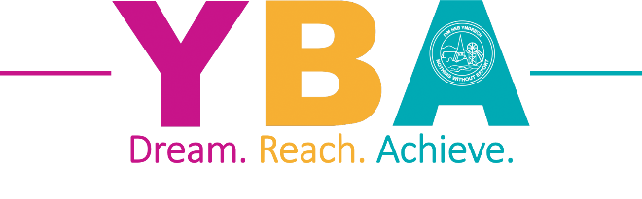
YSGOL BRYN ALYN
CHURCH STREET, GWERSYLLT, WREXHAM, LL11 4HD
Tel: (01978) 720700
Website: www. ysgolbrynalyn.co.uk
e-mail: mailbox@ysgolbrynalyn.wrexham.sch.uk

Headteacher: Mrs Adele Slinn, B.A. (Hons.) NPQSL, NPQH

Dear Parent/Carer, May 2026

Re: Year 11 – GCSE Examinations and Leaving Arrangements

I am writing to confirm the arrangements and leaving date for the Class of 2026.
As you are aware, the Summer GCSE examinations began on Thursday 7th May 2026. Your child will have already received their personalised exam timetable (two copies have been given) outlining the dates and times of their examinations, including their allocated seat.

Your child’s last official day at YBA will be Friday 22nd May 2026. After this date, Year 11 pupils will be expected to attend school for scheduled lessons where the corresponding examination has not yet taken place, and the expectation is that all pupils will attend their timetabled lessons before their exams. During this period, staff will continue to run subject-specific lessons and revision sessions to support students in preparing for exams scheduled later in the exam window. Please note that students must attend in full school uniform (this includes Leavers Hoodies – with shirt and tie on underneath) when coming in for revision sessions or lessons after 22nd May. In addition, we ask that all students sign in and out at the attendance office whenever they are on the school site, in accordance with safeguarding and health and safety requirements.

Please also be aware of the following expectations for attendance during exam sessions after half term:
- For morning exams, students must arrive at school by 8:40am. Breakfast club begins at 8am and is a good start to the day.
- For afternoon exams, students should arrive by 12:45pm to allow sufficient time to locate their allocated exam room and seating plan.

Arrangements for Friday 22nd May 2026:
- Pupils are expected to attend school in full uniform at the normal start time.
- During Lessons 1 and 2, students will sit their Physics GCSE examination.
- At 11:20am, pupils will proceed to the Top Hall for their Leavers’ Assembly.
- Following the assembly, students will enjoy refreshments with their form tutors and will have the opportunity to have their shirts signed.
- Please note, pupils are expected to have exemplary uniform for their final formal assembly at YBA. Pupils will not be allowed into the hall if their uniform is marked in any way, therefore, we kindly ask that pupils bring a separate shirt specifically for signing.
- School will finish for Year 11 students at approximately 12.30pm. If your child is unable to return home at this time, please contact me via email so that we can make arrangements to supervise them until the usual finish time of 3:00pm.

We are incredibly proud of our Year 11 students and the way they have conducted themselves throughout their time at YBA. We look forward to celebrating their achievements in the weeks to come and wish them the very best for the remainder of the exam season.
If you have any questions or require further information, please do not hesitate to get in touch.

Yours sincerely,

Mr G Jones - Head of Year 11


